Post Arcana / Damage System

**Table of contents**:

1. – Introduction................................................2
2. – Design Goals..............................................2
3. – System Behavior.........................................2
4. – Logical View...............................................3
   1. – High-Level Design (Architecture)........3
   2. – Mid-Level Design.................................4
   3. – Detailed Class Design...........................5
5. – Process View................................................6
6. – Use Case View.............................................8

**Change History**

**Version:** 0.1

**Modifier:** Danylo Cardoso

**Date:** 03/14/2022

**Changes:** Document created

**Version:** 0.2

**Modifier:** Danylo Cardoso

**Date:** 03/16/2022

**Changes:** Mid-level and High-level design added

**Version:** 0.3

**Modifier:** Danylo Cardoso

**Date:** 03/17/2022

**Changes:** Process view added

**Version:** 0.4

**Modifier:** Danylo Cardoso

**Date:** 03/18/2022

**Changes:** System architecture added

1. **Introduction**

This document describes the design and architecture of Post Arcana by the Hex Decimals. Post Arcana is a single player open world RPG, set in a post-apocalyptic small Canadian town after the introduction of magic to the real world.

The purpose of this document is to define the architecture and design of the damage systemin a manner that assists the interests of all major stakeholders. The major stakeholders and their interests are as follows:

* Developers: A design that is easy to implement that minimizes complexity
* Project Manager: A design that can be easily divided among the skills of the programmers
* Maintenance Programmers: A design that can be improved upon easily

# **2 Design Goals**

The design priorities for the damage system are:

• The design should minimize complexity and development effort.

• The design should make damage interactions between game objects clear to the developers.

# **3 System Behavior**

The damage system consists of the interactions between different game objects that leads to a reduction in their health stat and may lead to the game object’s death. Players may be damaged by contact with an enemy, and when damaged will get a temporary invincibility state. The amount of damaged exchanged is influenced by a character’s stats.

# **4 Logical View**

The logical view describes the main functional components of the system. This includes modules, the static relationships between modules, and their dynamic patterns of interaction.

In this section, the modules of the system are first expressed in terms of high-level components (architecture) and progressively refined into more detailed components and eventually classes with specific attributes and operations.

# **4.1 High-Level Design**

* GameObject: Base class for the game entities (Players and enemies). Stores abstract and concrete stats.
* Enemy: The class used for enemy-only stats and components
* AI Controller: Moves and controls the enemies
* Player: The class used for player-only stats and components
* Player Controller: Receives player input and controls the player
* Projectile: Is launched by the player, and deals damage to Game Objects
* Menu: Places a UI element on the screen given a specific input
* HUD: Shows the player important stats

# **4.2 Mid-Level Design**

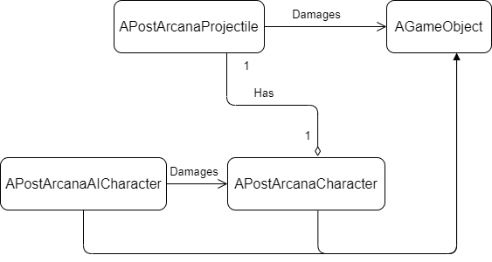

**AGameObject:** A character with health, stats, and a level. It can take damage, and if its health goes down to 0, it will die. The amount of damage it takes is lowered based on the value of the game object’s defence stat.

**APostArcanaAICharacter:** A game object that goes after the player and will attempt to damage them through contact. Can also be damaged by the player’s projectiles.

**APostArcanaCharacter:** A game object controlled through player input that can shoot projectiles which may damage enemies when they connect. Can also be damaged by contact with the enemy. When damaged by the enemy the player will be temporarily invincible.

**APostArcanaProjectile:** Bullet shot by the player that damages a game object that it comes in contact with. The amount of damage dealt is increased based on the player’s intelligence, and decreased based on the game object’s defence.

# 

# **4.3 Detailed class design of damage system**

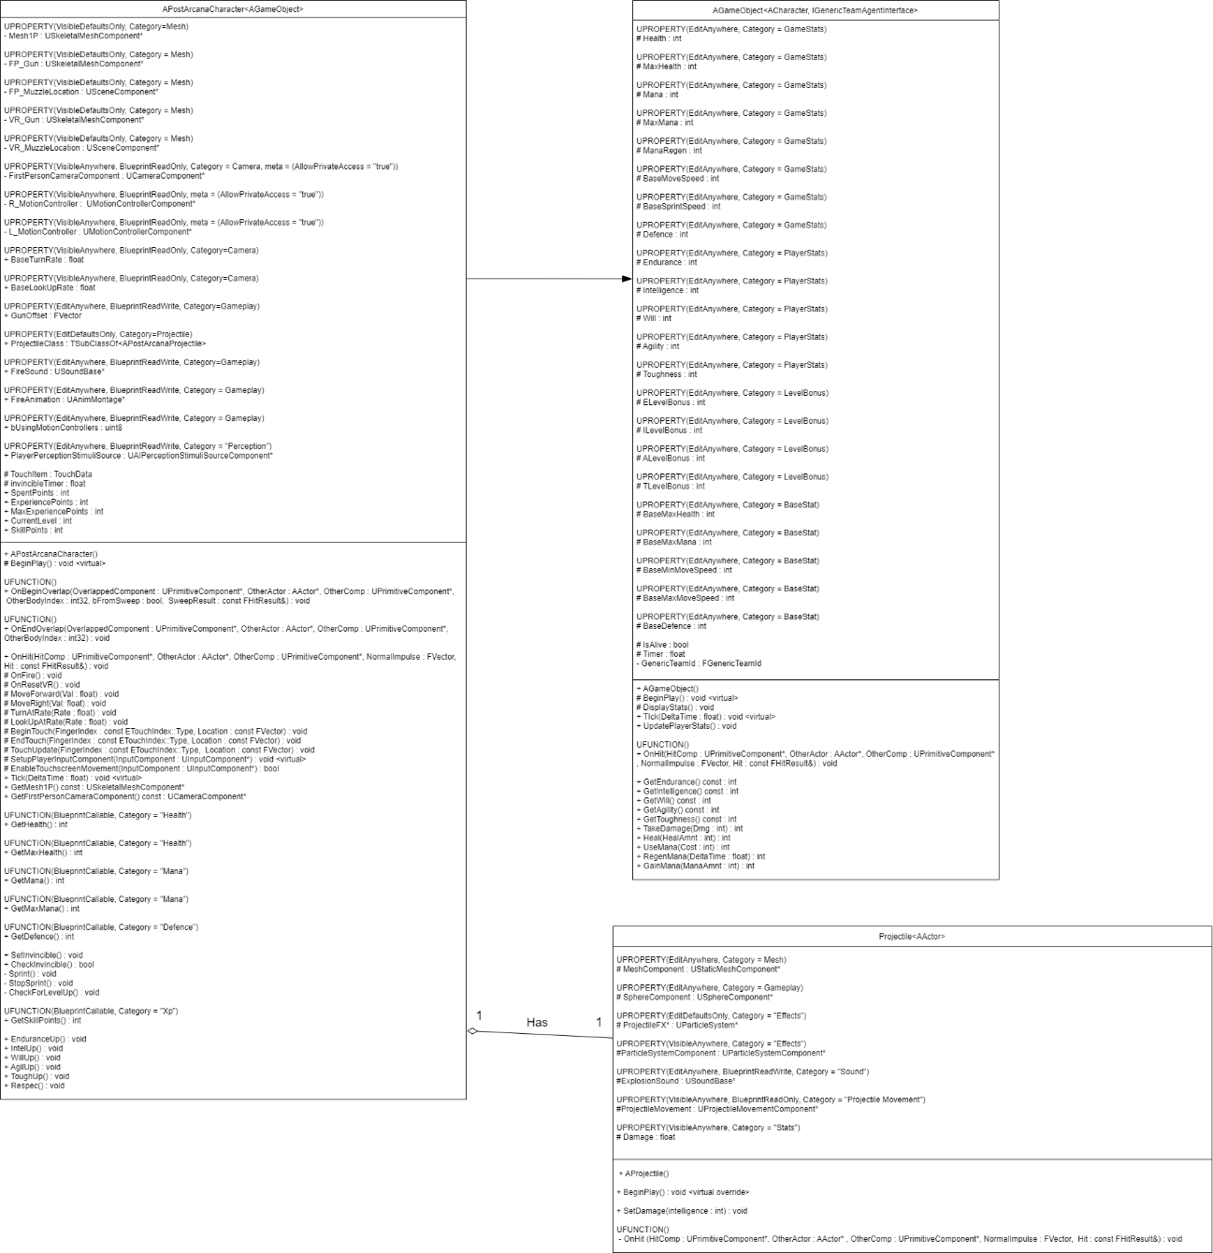

# **5 Process View of the Damage Module**

Enemy damages the player

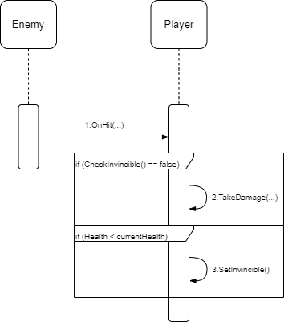

The enemy’s AI will make it chase the player. When contact happens between the player and an enemy, if the player is not in an invincibility state, the player will take damage. If the player takes damage, they will be put in a temporary invincibility state, to prevent them from getting too much damage at once.

Projectile damages game object

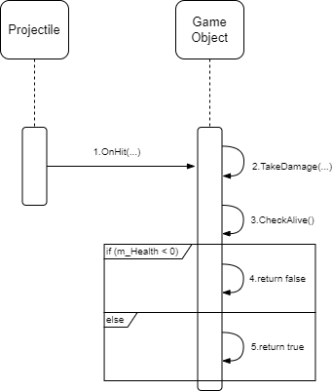

The player can shoot projectiles which they may use to cause damage to other game objects, usually enemies. When the projectile collides with a game object, said game object will take damage, and the value of that damage will be dependent on the player’s intelligence stat. After suffering damage, the game object will check if it is still alive or not, returning false if its health is less than 0. The amount of damage that the game object takes is reduced based on its defence stat.

# 

# **6 Use Case View**

**Testing and applying the damage system**

On “Content/StatTestObjs” there is an assortment of objects that apply and heal damage on the player character.

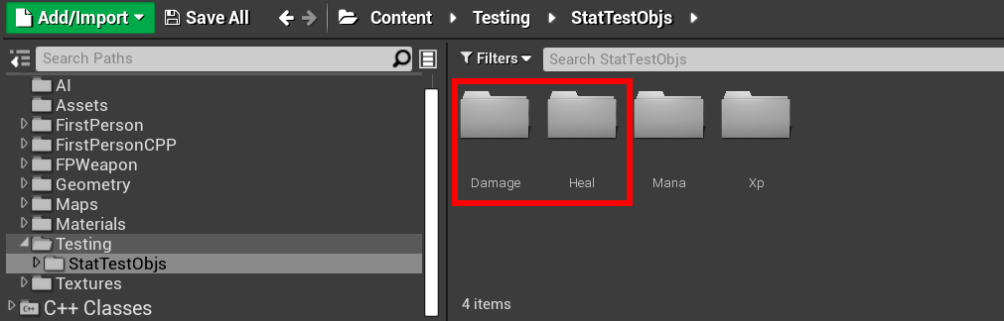

These can be used for testing the damage system and seeing it in action.

